Template ‘Save the Date’ email

When organising such workshops, it is useful to send a ‘save the date’ as early as possible, to maximise the chance of people being available to participate. As such, you will find a template ‘Save the Date’ email below which we suggest you adapt and send to the relevant CSOs in your country. You will find guidance of which types of CSOs to invite on P6 of the Guidance note for civil society organisations organising a Goal 16 Advocacy Toolkit workshop.
We suggest that you attach the flyer (also below) to the email, having added in the relevant details.
Save the date email*
Email subject: Save the Date! (Organisation’s name) is organising a Goal 16 Advocacy Workshop on (date and time)
Dear [Add the name of the potential participant],
We are organizing an Advocacy Workshop on SDG16: Peace Justice and Strong Institutions, on (date and time). Please find attached a flyer with the basic details of the workshop, which will focus on the TAP Network’s Goal 16 Advocacy Toolkit.
The workshop aims to help build civil society capacity on Goal 16, using the Goal 16 Advocacy Toolkit to discuss how to engage with governments and other local, regional and international stakeholders to support the planning, implementation, follow-up and accountability of Goal 16. It also aims to explore the possibility of working together in a Goal 16 national coalition.
Please save the date! We hope you be able to attend. A full invitation will follow shortly.
Best regards
(Insert name and signature of relevant staff member)

*Don’t forget to contextualise the email by adding in the date, venue etc

Template Invitation*

Dear [Insert the name of the potential participant],
In September 2015, world leaders agreed on the Sustainable Development Goals (SDGs) – a set of 17 Goals and 169 targets to guide global development. These goals are universal and potentially transformative in nature.
The 2030 Agenda reaffirms the wealth of evidence that ‘there can be no sustainable development without peace and no peace without sustainable development’. It also recognizes that good governance and strong and accountable institutions underpin development and peace-building efforts.
The focus around the SDGs has now shifted towards implementation, particularly at the national and local level. It is time for our governments to implement the SDGs in a participatory manner, and crucially, to implement Goal 16 and its targets.
To help (insert the adjective about your country, i.e. Cuban) civil society understand the issues pertaining to Goal 16, (insert name of your organisation) is pleased to invite you to participate in a TAP Network Goal 16 Advocacy Toolkit workshop we are organising on (insert date and date) at (insert venue). The workshop has the following objectives:
- To build civil society capacity on Goal 16, using the TAP Network Goal 16 Advocacy Toolkit to help organisations engage with and influence the relevant processes at the local and national level.
- To strengthen networks and identify ongoing opportunities for national level collaboration around advocacy on Goal 16
- To identify key entry points at the national level
- To develop a basic advocacy plan and advocacy messages around specific Goal 16 targets.
- To explore the possibilities of a national Goal 16 coalition.
If you would like to participate, please register via this link**, or contact us on (insert email address of the person responsible for the guest list)
Yours sincerely,
(Insert name and signature of relevant staff member)

Template Tweets
Objectives
- To promote the Goal 16 Advocacy Workshop
- To encourage CSOs to participate in the Goal 16 Advocacy Workshop
- To promote the TAP Goal 16 Advocacy Toolkit
- To build public interest in Goal 16 issues
- To build media interest in Goal 16 issues

Sample tweets*
- Join us for a workshop on #Goal16 Advocacy Toolkit to plan engagement w/ + influence on nat gov on date + venue http://bit.ly/232Y47u
- Work on #participation, #accountability or #transparency? Join us 4 #Goal16 Advocacy Toolkit workshop on date + venue http://bit.ly/232Y47u
- Interested in the #SDGs? Participate in a workshop on #Goal16 Advocacy Toolkit on date + venue http://bit.ly/232Y47u
- How can #civilsociety contribute to #Goal16 at national level? Join our workshop on @TAPNetwork2030 Advocacy Toolkit on date + venue
- Time for the government to implement #Goal 16. Help make this happen at our workshop on @TAPNetwork2030 Advocacy Toolkit on date + venue
- How should our government implement #Goal 16? Join the conversation at #Goal 16nameofyourcountry http://bit.ly/232Y47u
- Check out the@TAPNetwork2030 #Goal16AdvocacyToolkit for #SDGnational civil society. Join our workshop to learn more! http://bit.ly/232Y47u
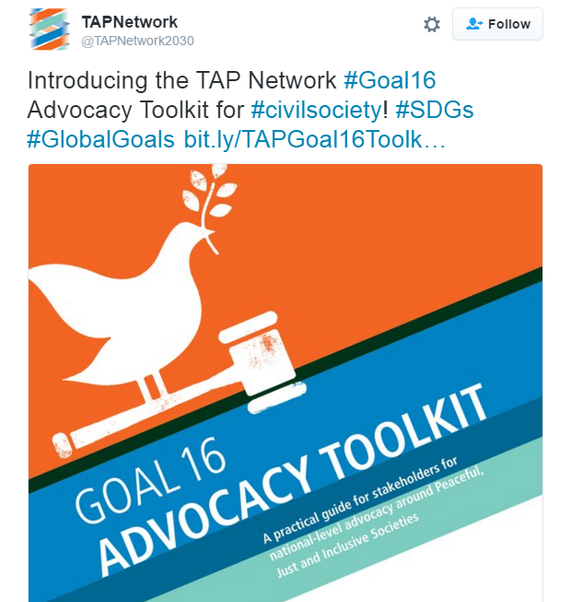
- How can #civilsociety contribute to #Goal16 at national level? Find out in @TAPNetwork2030’s new Toolkit http://bit.ly/232Y47u
Be sure to attach the graphic of the front cover of the Goal 16 Advocacy Toolkit to your tweets, as in the sample tweet about the toolkit from the TAP Network. You can find the Graphic here.
* Don’t forget to contextualise the tweets, adding the date and venue etc

Template Facebook Posts
Objectives
- To promote the Goal 16 Advocacy Workshop
- To encourage CSOs to participate in the Goal 16 Advocacy Workshop
- To promote the TAP Goal 16 Advocacy Toolkit
- To build public interest in Goal 16 issues
- To build media interest in Goal 16 issues

Sample Facebook post*
In September 2015, world leaders (including our President / Prime Minister etc) agreed on the Sustainable Development Goals (SDGs) – a set of 17 Goals and 169 targets to guide global development, universal and potentially transformative in nature.
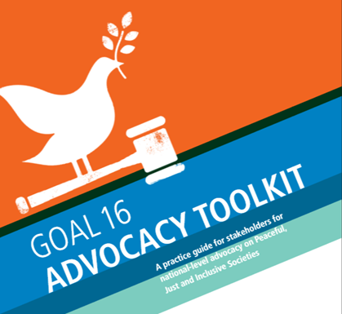
The 2030 Agenda reaffirms that ‘there can be no sustainable development without peace and no peace without sustainable development’. It also recognizes that good governance and strong and accountable institutions underpin development and peace-building efforts.
The focus around the SDGs has now shifted towards implementation, particularly at the national and local level. It is time for our governments to implement the SDGs in a participatory manner, and crucially, to implement Goal 16 and its targets. The TAP Network’s Goal 16 Advocacy Toolkit is a key resource to help civil society ensure that the government implements Goal 16.
Civil society is strong when we are together. Will you join us for a workshop on the @TAPnetwork2030’s #Goal16 Advocacy Toolkit, to discuss and plan engagement with governments and other local, regional and international stakeholders to support the planning, implementation, follow-up and accountability of Goal 16, and to explore the possibility of working together in a Goal 16 national coalition, on (Insert date + venue)?
* Don’t forget to contextualise the Facebook post, adding the date and venue etc

Sample Press Releases
In order to build public and media interest in Goal 16 issues, we recommend sending out a press release to journalists with an existing interest in governance and development issues, both before and after the event.
The press release before the event should include:
- Date
- Time
- Name of speakers
- Context
The press release after the event should include:
- Attendance
- Representation from different CSOs
- Representation from government or UN, if appropriate
- Quotes
Below you will find standard press releases for the events. However, each press release will need to be highly context specific, so we strongly suggest that you adapt the press release to your national context.
For further guidance on working with the media, we suggest looking at the following resources:
- Beyond 2015 media guide
- Engaging with the Media: Civicus / Stakeholder Forum / UN DESA

Press release to send before the event*
(Insert your logo)
(Insert headline): e.g. Civil society mobilises in favour of peace, justice and strong institutions.
(Insert your city, date) – In September 2015, world leaders (including our President / Prime Minister etc) agreed on the Sustainable Development Goals (SDGs) – a set of 17 Goals and 169 targets to guide global development, universal and potentially transformative in nature. The 2030 Agenda reaffirms that ‘there can be no sustainable development without peace and no peace without sustainable development’. It also recognizes that good governance and strong and accountable institutions underpin development and peace-building efforts.
(Insert a paragraph on what progress your government has made around the implementation of Goal 16 at the national level.)
On (insert date and venue), civil society will come together to plan effective engagement with our government, with the aim of supporting the planning, implementation, follow-up and accountability of Goal 16, aiming to create a more peaceful, more just (insert country name) with stronger, more accountable, more transparent institutions. We will also explore the possibilities of working together in a Goal 16 national coalition.
Notes:
- (Insert your organisation’s name) is (insert a line or details about your organisation) www.yourwebsite.com @yourtwitterhandle
- The Transparency, Accountability and Participation (TAP) Network is a broad network of CSOs that works to ensure that open, inclusive, accountable and effective governance is at the heart of Post-2015 sustainable development agenda, and that civil society are recognized and mobilized as indispensable partners in the design, implementation of and accountability for sustainable development policies, at all levels.
- The TAP Network’s Goal 16 Advocacy Toolkit was launched in April 2016, and workshops have been organized around it to support civil society efforts in XX countries.
- The meeting on XXXX is organised by (insert names of organising partners)
Contacts:
Name, position, organisation, email address, phone number, twitter handle
* Don’t forget to contextualise the press release, adding the date, venue, quotes etc

Press release to send after the event*
(Insert your logo)
(Insert headline: E.g. Civil society calls on government to end the scourge of corruption)
(Insert your city, date) – In September 2015, world leaders (including our President / Prime Minister etc) agreed on the Sustainable Development Goals (SDGs) – a set of 17 Goals and 169 targets to guide global development, universal and potentially transformative in nature. Today, civil society organisations came together to plan effective engagement with our government, with the aim of supporting the planning, implementation, follow-up and accountability of Goal 16.
(Insert short paragraph on attendance – provide details of influential CSOs, government, UN officials. Provide numbers and if appropriate, geographical spread of participants.)
The 2030 Agenda reaffirms that ‘there can be no sustainable development without peace and no peace without sustainable development’. It also recognizes that good governance and strong and accountable institutions underpin development and peace-building efforts.
(Insert name of the CEO of your organisation) said: “The focus of the SDGs is now primarily on the national and local level. It is time for our governments to implement the SDGs in a participatory manner, and crucially, to implement Goal 16 and its targets.”
(Insert one or two key outcomes of the meeting.)
(Insert a short quotation from another CSO.)
(Insert, if appropriate, short quotation from a government or UN official.)
The adoption of the SDGs in September 2015 was is historical, but today’s event was a reminder that much work needs to be done at the national level. Civil society stands ready to work for a strong implementation of Goal 16 in (insert country) and calls on the government to (insert key ask)
Notes:
- Your organisation is XXXXXX www.yourwebsite.com @yourtwitterhandle
- The Transparency, Accountability and Participation (TAP) Network is a broad network of CSOs that works to ensure that open, inclusive, accountable and effective governance is at the heart of Post-2015 sustainable development agenda, and that civil society are recognized and mobilized as indispensable partners in the design, implementation of and accountability for sustainable development policies, at all levels.
- The TAP Network’s Goal 16 Advocacy Toolkit was launched in April 2016, and workshops have been organized around it to support civil society efforts in XX countries.
- The meeting on XXXX, was organised by (insert names of organising partners)
Contacts:
Name, position, organisation, email address, phone number, twitter handle
* Don’t forget to contextualise the press release, adding the date, venue, quotes etc

